Arbuthnott Family Association



Newsletter 2011

Annual Gathering 2011 UK Branch,

This year the annual Gathering will be in London. We will once again be using the officer’s mess at the Inns of Court and City Yeomanry at Lincoln’s Inn. Officer’s Mess, Territorial Army Centre, 10 Stone Buildings, Lincoln’s Inn, London, WC2A 3TG

The Gathering will take place on Friday 7th October, at 6.30pm. The evening will start at 6.30pm, with drinks followed by a short AGM and then a buffet supper. The cost of the evening will be £30.00, including supper. Payment can be made on the evening.

The main purpose of the evening is to meet family and friends and we would welcome and encourage partners and friends to join us.

Please can you complete the reply form to let me know if you are able to come to the gathering, so that I can confirm the arrangements with Julian Allen. My email address is c.arbuthnott@btopenworld.com and telephone number 0131 441 1815.

Annual Gathering in October 2010 in London

We enjoyed one of our largest gatherings in London when we were once again able to enjoy the comfort and excellent facilities at the Inns of Court officer’s mess. We are delighted that we will be meeting in the same venue again this year thanks to the generous arrangements of Julian Allen. As well as having an opportunity to chat to people before the AGM there is a real family feel when sitting around the large mess table for supper.

There is great interest in the on-going work at Arbuthnott House and the support of the Arbuthnott Heritage Trust.

Visit to Arbuthnott House, 16th May 2011

Keith kindly agreed to show me (with husband, Julian, and 8 week old baby son, Kit, in tow!) around the restoration of Arbuthnott House so that I could give an update on the progress.
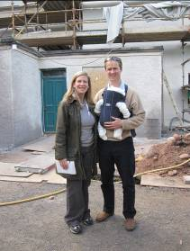
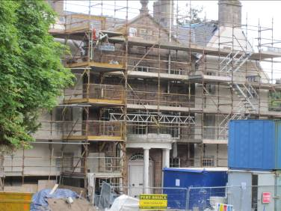

Katherine, Julian and Kit The front (west elevation) of the House

The extent of the work that is going on is, quite simply, staggering. Effectively, in Keith’s own words, they are “building a new house within old walls”. This is a huge undertaking, far greater than was originally envisaged and planned for last year, because almost every new task has uncovered more remedial work that has to be done to maintain the historic fabric of the building for the future.

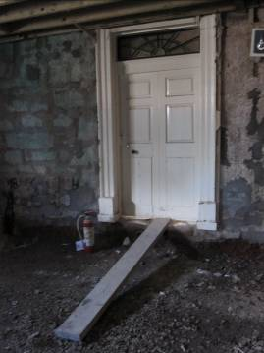
The whole house is sitting on the bare earth which has caused rising damp 3 feet up the walls on the ground floor. In addition to the lack of damp proofed foundations, there has been no proper heating in the house since 1939. After the war years, the coal fires were no longer used and central heating has never been installed. This lack of heat for the past seventy years has played a significant part in the deterioration of the building.

As a result of the damp, wet rot and dry rot has been rampant throughout the house. This has been treated but there is no guarantee that it won’t break out again. When the new heating system is switched on, it will take a while to dry the fabric of the building and further outbreaks may occur.

Earth foundations

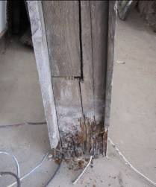
Almost every door lintel in the house has been found to be rotten and crumbling so each has had to be replaced.

Similarly, although the windows look fine from the outside of the house, their frames have been found to be rotten and have had to be replaced.

Unfortunately, a series of “patch up” jobs carried out by previous occupants doing what repairs and alterations they could on limited budgets, has taken its toll on the fabric of the building and the full cost is now coming home to roost.

A rotten window frame

The Outside

On the outside of the house, the cement harling (render) has been removed and replaced with layers of lime mortar that will allow the building to breathe. The removal of this harling has revealed some interesting historical clues underneath which show the chronological development of the house.

A structural deficit resulting in a bulge in the south wall (that was previously hidden under a climbing shrub) near the conservatory is now clearly visible from the outside. A relieving arch and a series of windows, dating from 1420 that were later blocked up without tying in to the rest of the stonework, has led to what is now a serious structural defect. It is recommended that this part of the wall be taken down and rebuilt to maintain a safe and sound structure.

From a historical point of view this throws up questions about the previous layout of the house. On the ground floor there may have been vaulted guest rooms, and the windows for these and others were later blocked up when the house became less of a ‘fort’ and more of convenient and comfortable domestic property suitable for the Viscount.

Charles McKean, Professor of Scottish Architectural History at the University of Dundee, has visited Arbuthnott House and suggested that there is evidence that the original dwelling from 1190 may have had four towers linked by a curtain wall. The foundations of two of these are still discernable, one in the lower courtyard and one within the existing house.

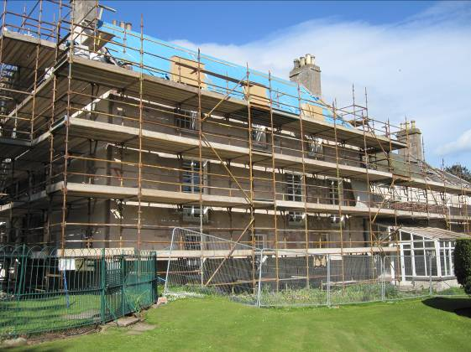
“The Bulge” – in detail below

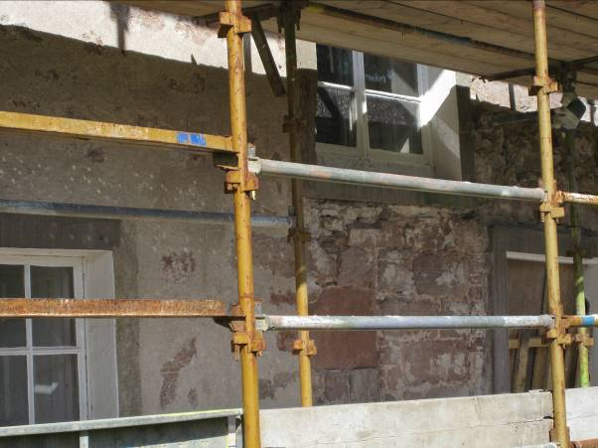

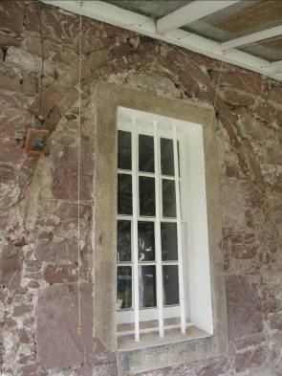
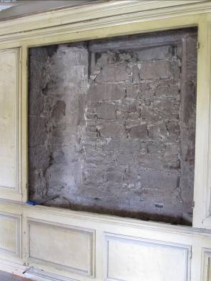
An old opening in the conservatory A blocked up window, seen from inside

The roof has been completely stripped and re-slated and much of the roof timbers replaced and the array of down-pipes on the exterior of the house has being rationalised. The 21st century convenience of having every window re-fitted so that it can be cleaned from the inside has been achieved.

To avoid having water storage tanks in the attic again, a new pressurised system has been installed in an outhouse near the back door, adjacent to the new pellet-fired central heating and HW boiler.

The Inside

All the furniture has been removed and taken to storage. The house is being completely re-plumbed and rewired allowing for TV and IT sockets in most rooms to reflect the needs of modern family life. Installation of a complete central heating system is underway using renewable biomass wood pellets as fuel, sourced and manufactured on the Arbuthnott Estate.

As you enter the house by the back door, there will be a new library where the gun room used to be. The bookcases from the old library will be reinstalled here after restoration. From here, you walk into what will be a brand new kitchen complete with contemporary appliances. All the floor joists in this room have had to be taken up and replaced or repaired as they were found to by lying directly on the earth and therefore having wet rot. These rooms have been moved around to accommodate the needs of a present day family as well as bring light to a kitchen that is now at the heart of the house rather than tucked away as in bygone days.

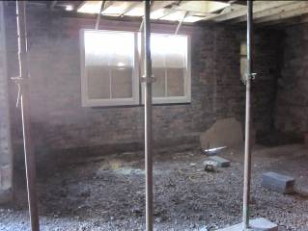
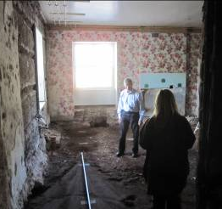
What will be the new library and the ”boot room”!

Aside from the alterations on the ground floor, the layout of the rooms on the upper floors is not being altered dramatically. The bathrooms will stay where they originally were (with new units) rather than making every bedroom en suite, again to preserve the feel of an 18th century house. All the floors on the first and second level are being strengthened and straightened and re-floored. Building restrictions on historic houses are such that double glazing the windows is prohibited so the attics are being insulated and shutters refurbished to keep in the warmth.

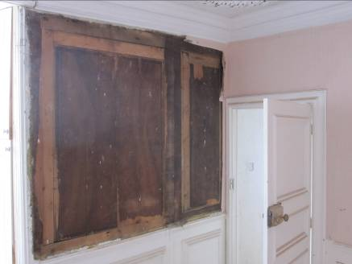
Paintwork has already started and when the wallpaper in the “Queen Mother’s room”, (so called because she “freshened up” there once) was stripped, a dark Kirkcaldy Veneer panelling was revealed, typical of the late 17th century when that room was created A section of the wall has been left as a point of interest.

The staircase is being re-plastered from side to side all the way down due to dry rot. The cupola will be double glazed using Histoglass, a system specifically developed for the restoration and renovation of historic buildings. It will also be raised six inches to shed any water and be completely re-plastered and re-leaded outside.
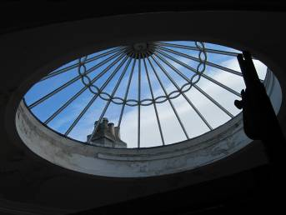
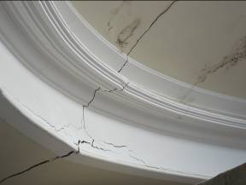
The cupola, with cracks in plasterwork due to water ingress

Whilst every effort is being made to keep as many of the house features as possible, there are times when compromises have to be made for the sake of cost and efficiency. Most of these are out of sight though and a real effort is being made to retain as much of the original character of the house as possible.

Addendum: August 2011

This is by no means an exhaustive list of the work taking place at Arbuthnott House. I wanted to give you some idea of the vast array of repair and restoration work that is underway. It is nearly a year since the renovations started. The aim was to finish them by this September but the amount of work that still needs to be done, due to the kind of unforeseen problems I have mentioned, means that it will all take a good deal longer than expected.

Thanks to Keith’s untiring efforts and steadfast vision, the result will be that Arbuthnott House is brought into the 21st century hopefully in fantastic shape. These works will be a lasting legacy from him that will safeguard the House for many generations to come.

I would like to take this opportunity to remind you about the Heritage Trust which is supporting this project and thereby helping to preserve our family’s heritage for the future. Any donations will be very gratefully received. Cheques can be made out to “The Arbuthnott Heritage Trust” and sent to the AFA Treasurer.

Family Website,

The family genealogical website has proved to be an excellent source of information for all Arbuthnot(t)s. Anyone who has not had a chance to view the site should register on line with www.kittybrewster.com Please contact either myself, c.arbuthnott@btopenworld.com or Sir William Arbuthnot, Family Genealogist, arbuthnot@kittybrewster.com if you have any items of family news which should be added to the website.

Merchandise

We have new stock of the very popular woollen scarf, made this time by Johnstons of Elgin in a lovely soft lamb’s wool.

There is a stock of merchandise held for sale which includes woollen scarves, ties, bow ties, woollen shawls, silk head squares, travel rugs and photo frames. All made in tartan.

The tartan cloth is stored by the weaver at the mill and can be ordered from the secretary to be sent out direct.

All enquiries to c.arbuthnott@btopenworld.com or telephone number 0131 441 1815

Newsletter by E-mail.

The database of e-mail addresses is increasing and I am keen to capture as many as possible so that the newsletter can to distributed electronically to as many people.

If you receive the newsletter in black and white by post and you would like to receive a colour copy by e-mail, please can you send me your e-mail address? Also, there maybe some people who receive the newsletter twice, once by post and secondly by e-mail, again please let me know and I will stop the postal copy.

Please can you send me your e-mail address to c.arbuthnott@btopenworld.com

Charles Arbuthnott 0131 441 1815 August 2011
7A Woodhall Bank, Edinburgh EH13 0HL

Reply Form.

Name
Address

Telephone number
e-mail address

Family Gathering Friday 7th October 2011

Yes, I will be attending the Gathering on Friday 7th October in the Inns of Court and City Yeomanry Officer’s Mess.

Cost £30.00 per person How many? ……..

Please return to Charles Arbuthnott
7A Woodhall Bank
Edinburgh
EH13 0HL

e-mail c.arbuthnott@btopenworld.com

telephone number 0131 441 1815

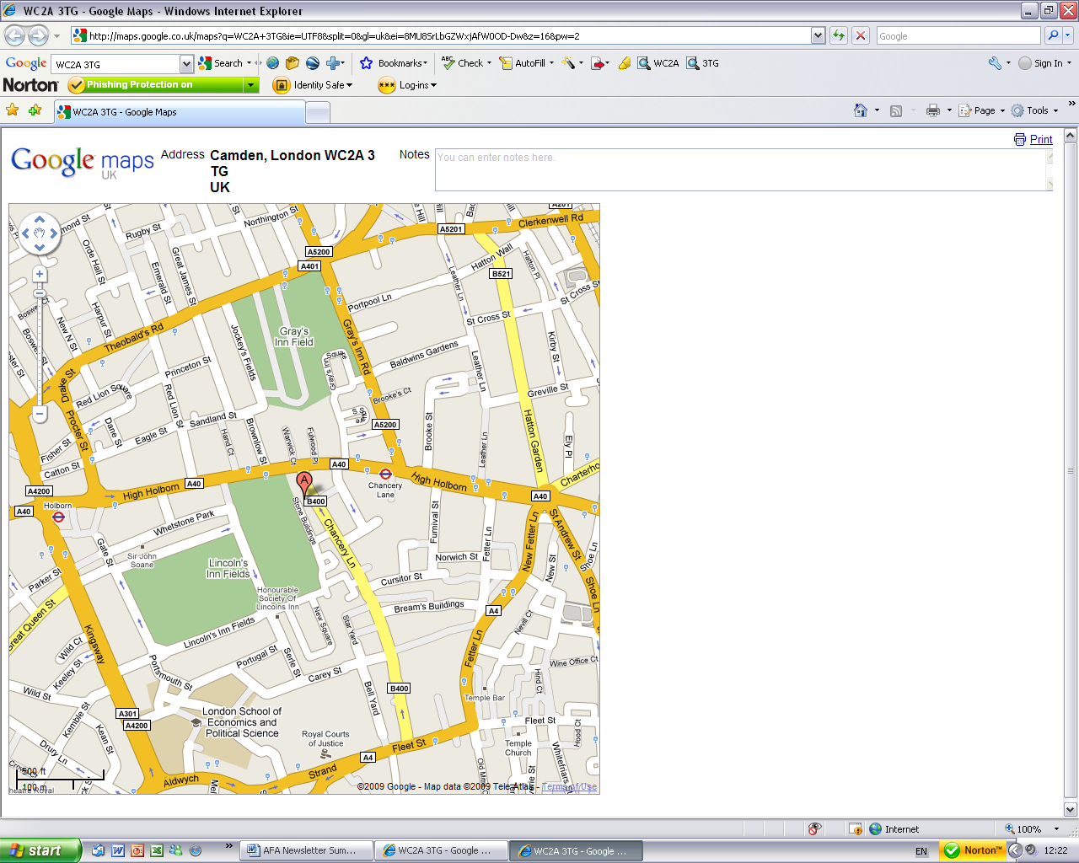
By car:
Lincoln’s Inn lies off A4200 Kingsway and A40 High Holborn. The entrance gate is through an arch on the east side of Lincoln’s Inn Fields. Please ask for 10 Stone Buildings and you will be directed to the car parking spaces outside.

By tube:
The nearest tube is Holborn on the Central line.
Walk round Lincoln's Inn Fields to the east side. Turn left through the arch into New Square. Turn left again after the War Memorial. Walk past the chapel on your right. You will come to a cul de sac lined with terraced houses on either side. 10 Stone Buildings is up on your right next to the Territorial Army sign.

10, Stone Buildings, Lincoln’s Inn, London, WC2A 3TG

